Perioperative Quality Improvement Programme
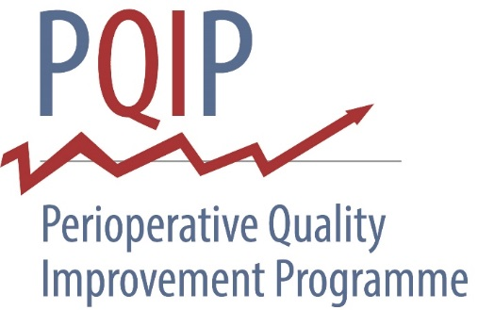
Patient Consent Form
One copy should be given to the participant, one copy placed in their medical notes and one copy retained by the research team

Patient Details
Surname

To be completed by the hospital
Hospital

Forename

NHS number

Date of Birth

Phone number (for contact on Day 3 if discharged from hospital)

Email address (for contact for questionnaires at 6 months and 12 months after surgery)

Would you prefer to be contacted by telephone or email to complete questionnaires in 6 and 12 months’ time? Phone Email Don’t mind
I would like to receive updates on PQIP from the study team, approximately once a year, by email:

Yes please No thanks Please initial

- I confirm that I have read the participant information sheet dated 07/11/2017 (version 1.0) for the above study. I have had the opportunity to consider the information, ask questions and have had these answered satisfactorily.
- I understand that my participation is voluntary and that I am free to withdraw at any time without giving any reason, without my medical care or legal rights being affected. If I choose to withdraw, I understand that no further information will be collected about me, but anonymous information provided may still be used for research.
- I understand that relevant sections of my medical notes and data collected during the study, may be looked at by individuals from the Royal College of Anaesthetists, from regulatory authorities or from the NHS Trust, where it is relevant to my taking part in this research. I give permission for these individuals to have access to my records.
- I understand that the information collected about me will be used to support other research in the future, and may be shared anonymously with other researchers.
- I understand that personal details will be shared with NHS Digital (England), NHS Wales Informatic Service (Patient Episode Database for Wales, Wales) or NHS National Services Scotland (Scotland) to obtain information held by them and the Office for National Statistics in order to provide details about my health status and hospital admissions that are not otherwise collected by the PQIP study (see patient information sheet for more details).
- I agree to take part in the above study.

NAME: _ SIGNATURE:
DATE:

To be completed by the hospital (person accepting patient consent)
Name Signature

Position Date

PQIP Patient Study, IRAS number 215928, Consent Form v1.0 16.06.2017

